**PYTHON VERSION MANAGEMENT**

**Installed Python**

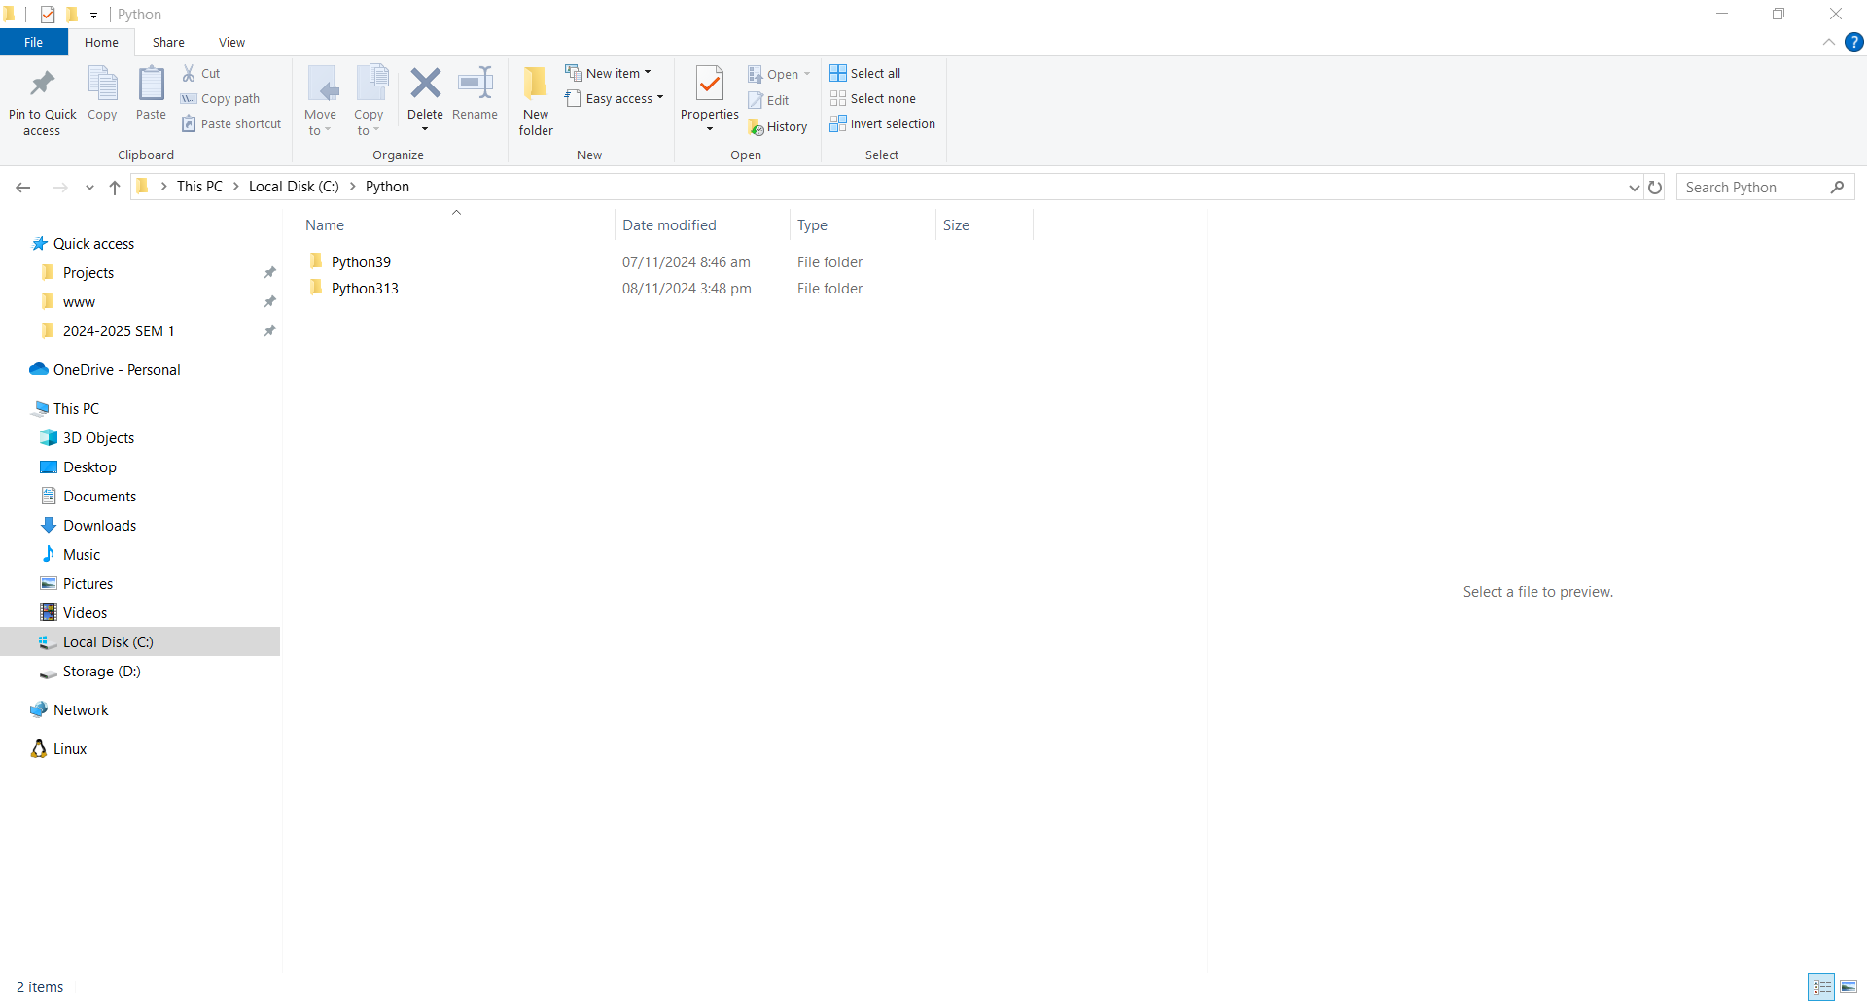

**Environment Variables**

**Using Python**

**3.9**

**3.13**

**Default**

**Creating Alias**

Create aliases for different Python versions and use those aliases as commands in the Windows Command Prompt.

**Use Batch Files**

Create batch files to serve as aliases for each Python version.

1. **Locate Python Executables**: Find the installation paths for your Python versions, e.g.,:
   * Python 3.9: C:\Python\Python39\python.exe
   * Python 3.13: C:\Python\Python313\python.exe
2. **Create Batch Files**:
   * Open Notepad (or any text editor) and enter the following:

* Save it as python39.bat & python313.bat (or any name you want) in a folder included in your system's PATH environment variable. For example:
* Save it to C:\Scripts.

**Include it in your system's PATH environment variable**

**Using Alias as Command**

You can now easily use/switch into any python version.

**For Multiple Python Version Installed:**

* Create virtual environment with specified version

`py -3.9 -m venv myenv39`

* Activate virtual environment

`myenv39\Scripts\activate`

* Check Python Version

`py --version`